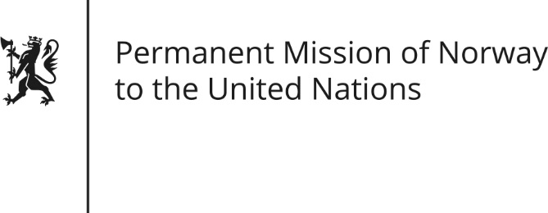

STATEMENT by Minister Counsellor Herborg F. Alvsaaker

Universal Periodic Review 27th Session. Review of Finland

3 May 2017

Check against delivery

Mr. President,
Norway commends Finland’s commitment to comply with international obligations and to promote human rights and transparency making Finland in our view a leading Human Rights supporter.
Concerning the rights of indigenous people, we commend Finland for the Government commissioned study (published in 2017) in support of the discussion about Sami rights. We understand that there are still outstanding issues surrounding the process to secure Finland’s ratification of ILO Convention No 169. We recommend that Finland engages the Sami people in the ratification process.

Thank you,

